**TESTING THE VALIDITY OF THE NORMAL DISTRIBUTION FOR THE ANALYSIS OF THE PRECIPITATION IN BELGRADE**

NIKOLA NIKOLIĆ

*Kumodraška 158c*

**INTRODUCTION**

“Working on studies of meteorological elements such as: air temperature, air pressure, humidity, cloudiness, wind speed vector component, amounts of precipitation, it is necessary to know their law probability distribution. (Jevremović i Mališić ).” The type of distribution law and distribution law parameters are determined on the basis of experimental data, because it is impossible to determine the type of distribution based on the physics of flow phenomena. Usually the next step in the study typically is determining the appropriate parameter values for the selected model of the distribution. In the end, using hi square test examines the validity of the proposed distribution.

Normal (Gaus) distribution is the most common distributions in statistical analyses. It is also the most studied distribution. More various trials found that amounts of precipitation have a distribution that is close to normal.

**METHOD OF OPERATION**

Used data on annual amounts of precipitation measured at the meteorological observatiry in Blegrade, form 1936. to 2014.

Random variable *X* (rainfall) has a normal distribution with parameters m and σ2  if the density distribution is:

, *x,m* ∈ R, and σ > 0

The parameters of the distribution are determined on the basis of a sample:

, 

Hi square test

This is a nonparametric test because it tests the hypothesis of the distribution of the random variable.

Statistics which tested the hypothesis is:



If the value of the test statistic is greater than tablet statistic, hypothesis is rejected. Otherwise the hypothesis is accepted.

**RESULTS**

To calculate the parameters of the normal distribution, data processing and displaying the chart we used Excel 2007.

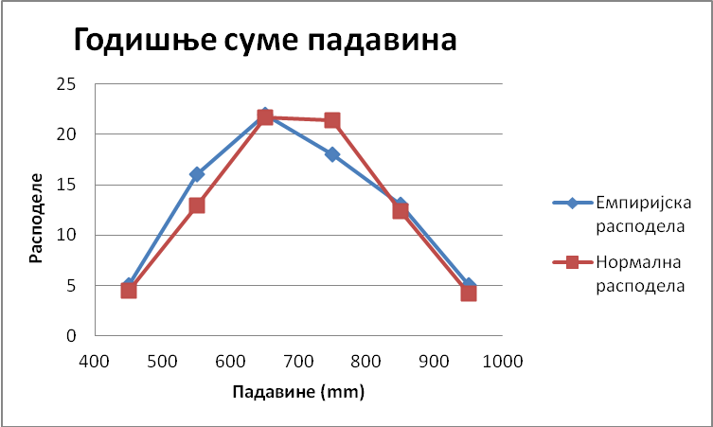

Picture 1. Graphics empirical and normal distribution obtained on the basis of data on annual precipitation after the compression of data at intervals

**CONCLUSION**

The research results show that the statistical value of less than 1.5296 7.8147 tablet so it can be concluded that annual precipitation adapt to a normal distribution.

**LITERATURE**

 V. Jevremović, J. Mališić, Statističke metode u meteorologiji i inženjerstvu, Beograd, 2002.