EXAMINATION OF SCALAR A PROPERTIES IN bA→bbb PROCESS
Author: Jovan Mitić, 4th grade student of „XIII Belgrade high school“
Supervisor: Lidija Živković, Institute of Physics University of Belgrade
Regional Centre for Talented Youth Belgrade II, Ustanička 64, Joxy97@yahoo.com
1. Introduction
The Standard model is currently valid and confirmed theory in physics which successfully explains and classifies fundamental particles as well as electromagnetic, weak and strong nuclear interaction between them. Although very successful model in description of how the universe works, it can’t explain gravitational interaction, the existence of dark energy and matter, neutrino oscillations and dominance of matter over antimatter. Anyway, there are suggested theories which hypothetically complement Standard model but for which evidences are still being searched for in the real world. One of them is a supersymmetry theory (SUSY) which has the existence of the range of particles connected to particles from Standard model as a consequence, which number is additionally reduced in minimal supersymmetric standard model (MSSM). Examination of properties of these particles in “event simulators” is crucial for their understanding and finding ways to discover them. One of these particles is A particle which is one of the five Higgs bosons which exist in MSSM. The aim of this project is to examine properties of A scalar which is produced together with b quark and which decays into two b quarks.
2. Materials and methodology
For the purposes of this project, CERN’s software for physical analysis ROOT was used, as well as well as data obtained in simulation generated in Monte Carlo generators. The process from the Picture 1 was simulated, where the supposed mass of A scalar was 250GeV/c². Statistically arranged parameters for 100 events were obtained:
nJet - number of jets in event
p_{t} - momentum magnitude of produced jet in transversal plane
η - pseudorapidity calculated as $η=-ln⁡(tg\left(\frac{Φ}{2}\right))$, where Φ is the angle between vector $\vec{p_{t}}$ and x-axis.
θ - angle between jet’s momentum vector and vertical axis
Е - energy of jet
MVA - multivariance technique for determining whether jet is b quark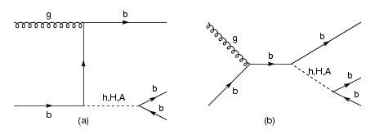
Picture 1. - Types of bA→bbb process
Using a built-in function, four-dimensional Lorentz’s vectors were formed based on these parameters for produced jets where p_{t}, η and θ are space variables while Е is the transformation of the time coordinate. As we have
 | $$p_{x}=p_{t}∙cos⁡(2arctg\left(e^{-η}\right))$$ | (1)
 | $$p_{y}=p_{t}∙sin⁡(2arctg\left(e^{-η}\right))$$ | (2)
 | $$p_{z}=\frac{p_{t}}{tg(θ)}$$ | (3)
it is possible to calculate the magnitude of momentum vector p via formula (4):
 | $$p=\sqrt{{p_{x}}^{2}+{p_{y}}^{2}+{p_{z}}^{2}}$$ | (4)
Afterwards, it is possible to calculate the mass of the particle via formula (5):
 | $m=\sqrt{E^{2}-p^{2}}$, $c=1$ | (5)
With comparison of mass found in such a way, two vectors of created b quark jets with the sum of masses closest to the mass of A scalar were found. Calculated sum of these two vectors is a four-dimensional Lorentz’s vector which describes the properties of A scalar.
3. Results and discussion
Since the project is still in developing phase, further text describes the expected results.
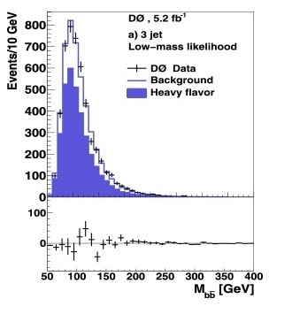
Picture 2. - Expected look of histogram with background event [1]
Histogram is expected to have wider distribution over mass and narrower peak at the place of expected resonance. Each b quark which originates from А scalar should have mass around 125GeV/c².
4. Conclusion
The analysis of simulated events in particle colliders is crucial for understanding particles proposed by the newest theories which explain how the universe works. with this project a successful analysis of A scalar properties is expected. The analysis of signal efficiency depending on selection is also planned in further research.
5. Refferences
[1] Abazov, V. M., et al. "Search for Higgs bosons of the minimal supersymmetric standard model in collisions at." Physics Letters B 710.4 (2012): 569-577.

